HIGHWAY CLEAN-UP Your HELP is needed
Highway Clean-up Fundraiser
Saturday, May 6 – 7:00 AM-1:00 PM
30+ Volunteers Needed; students ages 9+ can help too with a parent.
Help us raise $3700.00 in just a few hours for CES by spending some time outdoors helping with the annual highway clean-up fundraiser. Get your steps in, some fresh air and help our students at the same time.
https://signup.com/client/invitation2/secure/1247024838274706042/false#/invitation

April Hot Lunch

April 5 -Taco in a Bag
April 19-Hot Dog Day
April 26-Pizza by the Slice

Coalhurst Elementary School Newsletter

Thanks for your Support!
The recent Scholastic book fair helped us to add more than $3000.00 in new books to our library. Your support is always appreciated.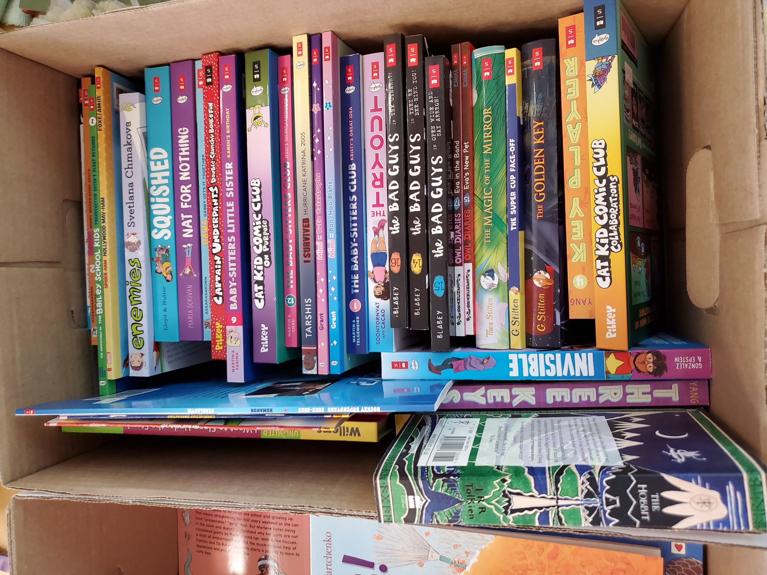

EDSBY & Report Cards
Please log into the EDSBY app and check out your child’s report card. These were published on Tuesday, March 28.
Please also use the app for attendance, not Class DOJO.
Contact the office by email if you do not have access to your children in the Edsby app.

April 2023

Monday | Tuesday | Wednesday | Thursday | Friday
3 | 4  Grade 3-4 Swimming | 5  Taco In a Bag  6:30 Parent Council Meeting | 6  Green Shirt Day-(Organ Donation) | 7  Good Friday
10  Easter Break | 11  Easter Break | 12  Easter Break | 13  Easter Break | 14  Easter Break
17  Lunch time Running Club Starts | 18 | 19  Hot Dog Day  Glow Dodgeball | 20  Glow Dodgeball | 21  ELP & Kindergarten Developmental Check Up Day
24  Grade 5-6 After school Badminton Club starts. | 25 | 26  Pizza by the Slice  Spring Picture Day | 27  Anything but a Back Pack Day!  Last day to Order May Hot Lunch | 28
1 | 2 | 3 | 4 | 5  Saturday

